Setting up Permissions
By
Joseph Tierney

Class: Computer Science 2

Tutor: Tony Bernes

Once the three users from the previous task had been set up, I then created an organisational unit called Joey. To do this, open server manager and expand Roles, expand Active Directory Users, right click and click on Organisational Unit.

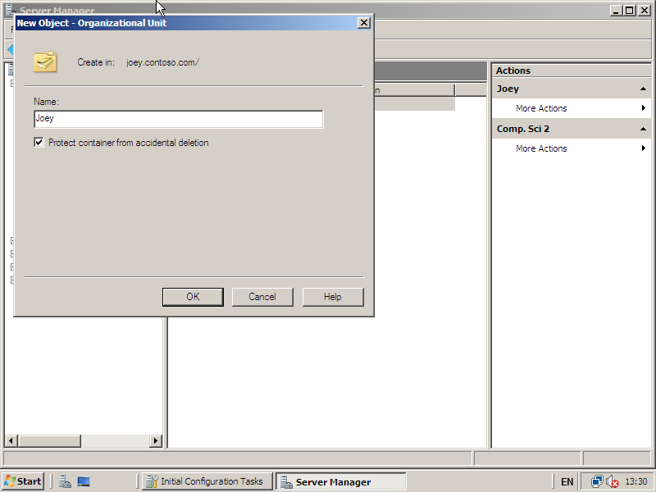
I then created a group within that organisational unit called “Comp. Sci 2”

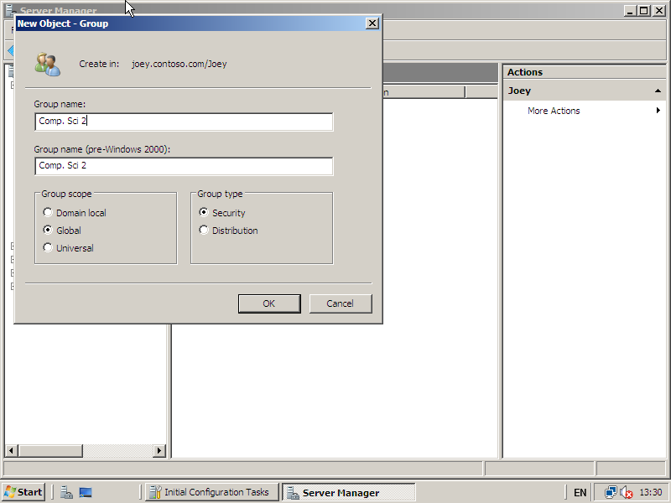

After the group had been created, I added the three users that I created into the group.

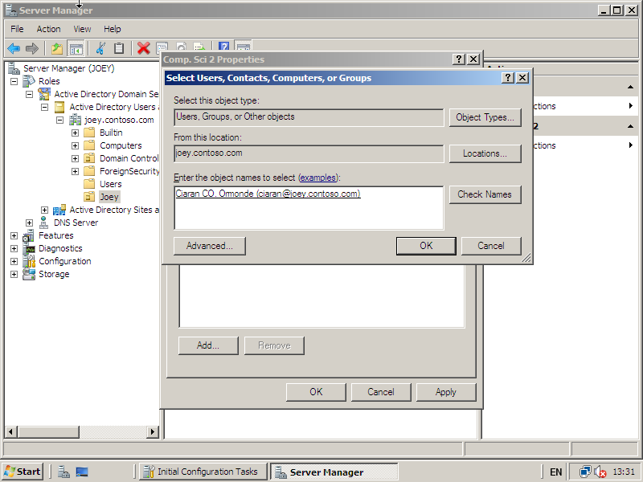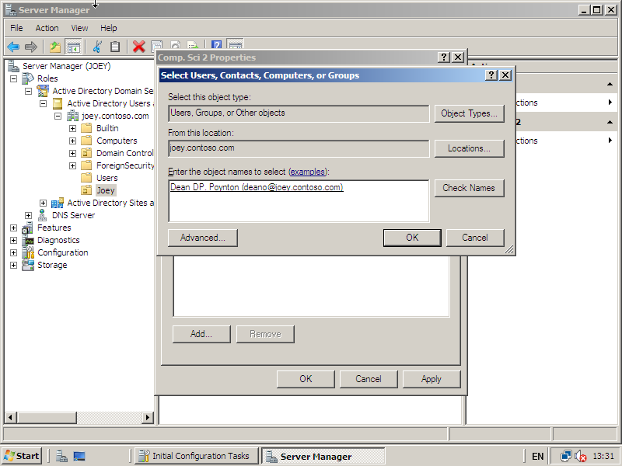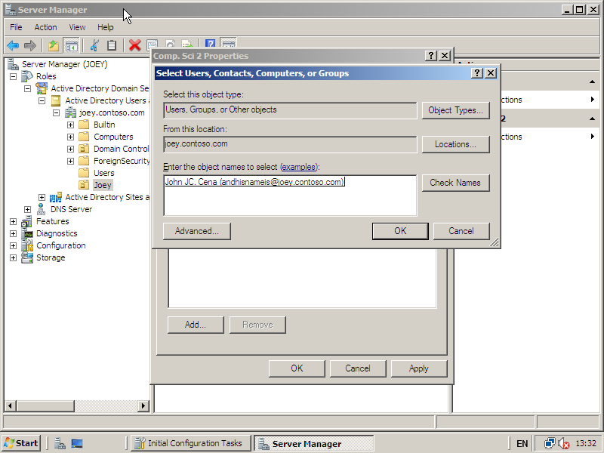

Once they had been added, I then set permissions for the users in that group by going to Delegation of Control. Right click on the name of the Directory and select Delegate Control.

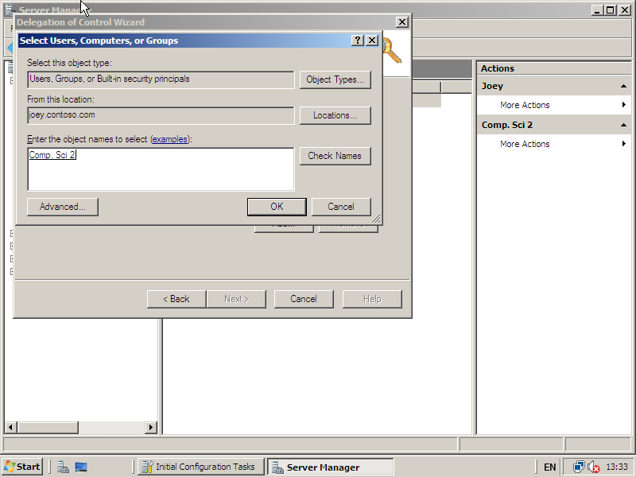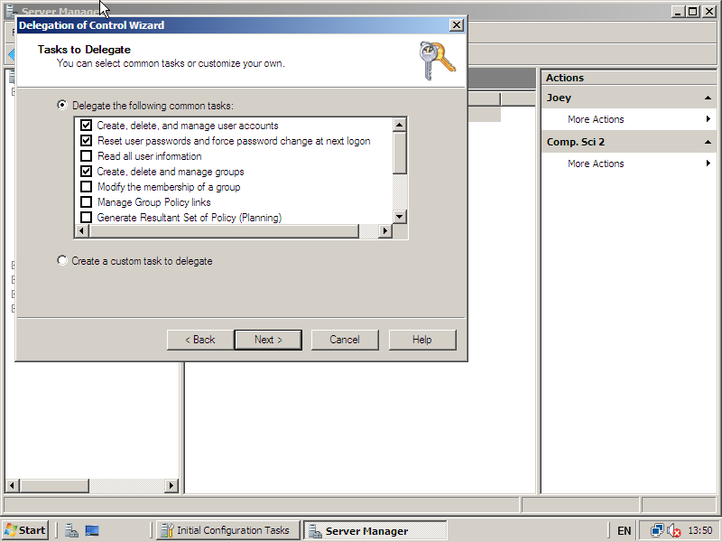
In this Tasks to Delegate window, select any of the tasks and click Next.
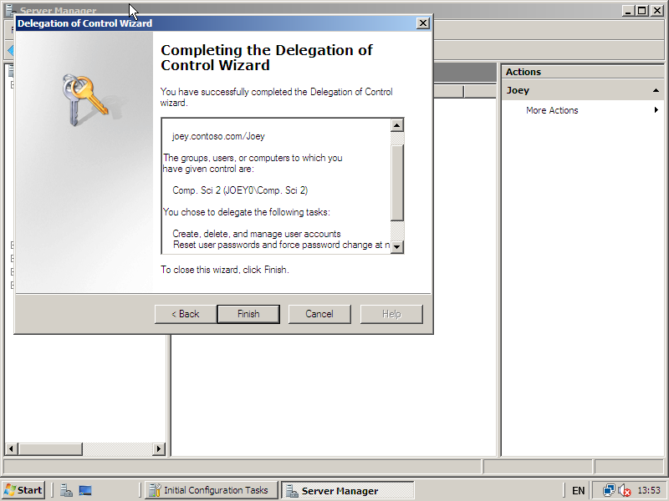
Click Finish.

